DESSA Mini Screener- Directions- Prospect School
DESSA mini screener should be completed by the classroom teachers. It is 7 questions about each child. The child does not need to be next to you when completing the screener.Please follow the directions to complete.
Logging in to Branching Minds
Go to the Prospect Website.
Click on the Teacher/Staff Tab.
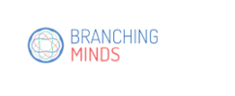
Click on Branching Minds to log in.

Select the blue box – Log in at branchingminds1.onmic and it should take you in.
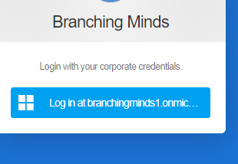

How to Administer the DESSA Screener

-Click on Action tab
-Select administer DESSA assessment
-Click on all of the students in your class (to check off the boxes next to their name)
-Assessment window- Fall 2022-2023 / Assessment DESSA Mini/Screener
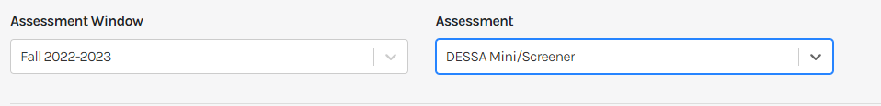


Press start next to the child’s name to begin the screener.

Complete all 7 questions and then press submit on the bottom. Complete for all students.
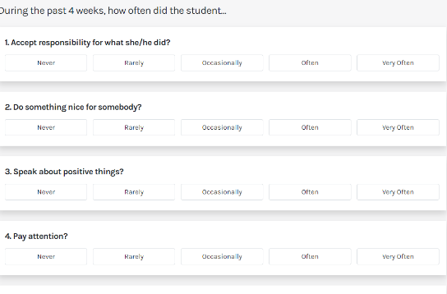

Video for help: https://watch.screencastify.com/v/Pr5B7UdZyvK7ECJ0AbjN

